*-Project Report Title-*

**PROJECT REPORT**

***Submitted in partial fulfillment of th*e *requirements for the award of the degree***

***Of***

**-BACHELOR OF TECHNOLOGY-**

***In***

**-COMPUTER SCIENCE-**

***By***

**-Amisha Sahu(00701012019),Sarita Yadav(01101012019),**

**Aditi Vishwakarma(02401012019),Anshika(02901012019)-**

***Guided by***

**-Dr. Vivekanand Jha-**

**-Vivekanand Jha-**

**-Computer Science Department-**



**INDIRA GANDHI DELHI TECHNICAL UNIVERSITY FOR WOMEN**

**NEW DELHI – 110006**

**- 3rd semester -**

**UNDERTAKING REGARDING ANTI-PLAGIARISM**

We, -**Amisha Sahu,Sarita Yadav,Aditi Vishwakarma ,Anshika*-*** hereby, declare that the material/ content presented in the report are free from plagiarism and is properly cited and written in my own words. In case, plagiarism is detected at any stage, We shall be solely responsible for it.

**-Amisha Sahu(00701012019),Sarita Yadav(01101012019),**

**Aditi Vishwakarma(02401012019),Anshika(02901012019)-**

**ACKNOWLEDGEMENT**

We would like to express our special thanks of gratitude to our teacher **Dr. VIVEKANAND JHA** who helped us to build our interest on the subject **DATA STRUCTURES** . He gave us this golden opportunity to work on the project **STUDENT MANAGEMENT SYSTEM**. It was the great opportunity for learning as well as to enhance our professional development. We would also like to thank our parents for mental support during this course of time. They co-operated and encouraged us to complete this project in a particular period of time.We learned a lot of concepts that were used in our project. This project helped us to feel confidence enough to do any project and coding over it. And we got a lot to learn which will help us in the future course of time.Also our ability to work in a team got enhanced. Once again a special thanks to all who helped us to complete this. This was a great opportunity for us.

**-Amisha Sahu(00701012019),Sarita Yadav(01101012019),**

**Aditi Vishwakarma(02401012019),Anshika(02901012019)-**

**OVERVIEW OF THE SYSTEM**

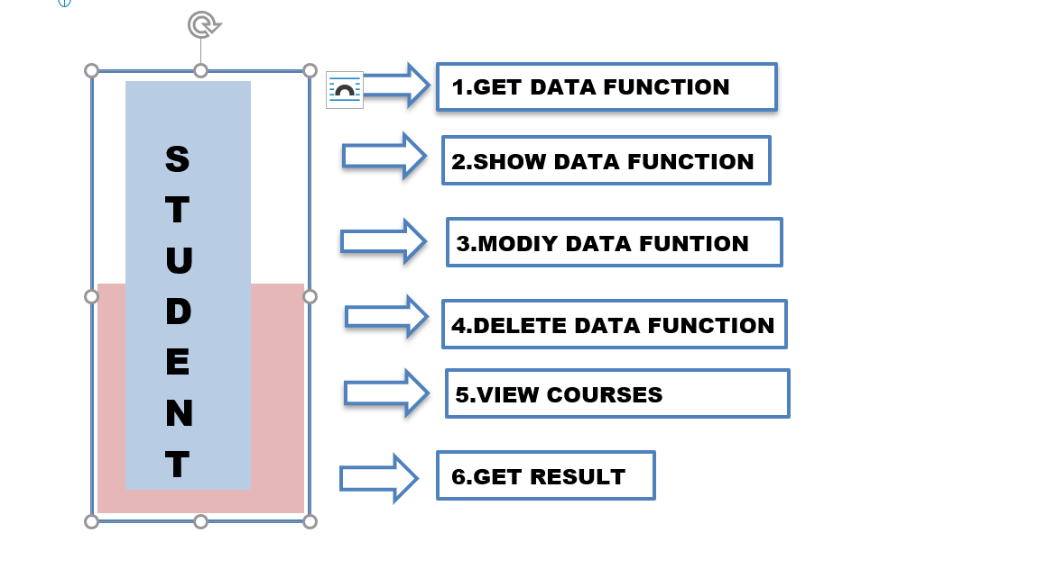

**SUMMARY**

The student management system is a system which will keep records of the students of a university where students can enter their data. This system is divided into two parts student login and admin login . Students can only see their records but cannot make any kind of changes in it. This can be done only by the admin. Admin login is protected by a password so that students may not misuse of the system. System will permanently store data into a file,students can search if their record is inserted or not, whenever required. Students can ask admin to update any information whenever required and they can also delete any record .The course function will show all the courses to be followed in particular semester .The result function calculates cgpa from marks .This is can be used in any educational institute for maintaining the record of student and proper access of the same.

**INDEX**

Undertaking regarding anti plagiarism ……………………………………...…... 1

Acknowledgement ………………………………………………………....……. 2

overview of the system……………………………………………………………3

Summary………………………………………………………………………….4

1. **Introduction**………………………………………………………………6
2. mainmenu………………………………………………………………….7
3. headerfiles…………………………………………………………………8
4. class-student……………………………………………………………….9
5. file handeling……………………………………………………………..10
6. getdata,adddata…………………………………………………………...11
7. showdata………………………………………………………………….12
8. displaydata and search data……………………………………………....13
9. delete data and gettrash…………………………………………………..14
10. modifydata……………………………………………………………….15
11. courses…………………………………………………………………....16
12. result……………………………………………………………………...17
13. student view and admin view…………………………………………….18
14. student login and admin login…………………………………………….19

--------------------------------------------------------------------------------------------------

**INTRODUCTION**

We made a project on the topic named STUDENT MANAGEMENT SYSTEM. This project is all about the record of the student in any university. We implemented the code in the language C++ because all our group members were familiar with it. Student management system is an environment where all the processes of the student in the institution are managed. This system saves the time of the student and of the administrator. It includes processes like registration of the student’s details, assigning the department based on their course and maintenance of the record. This system reduces the cost and workforce required for this job. As the system is online the information is globally present to everyone. This makes the system easy to handle and feasible for finding the omission with updating at the same time. This project will handle multiple tasks through various functions used in the code. The various functions used in the code are student login(), admin login(),get data(), add data(), show data(), display data(), search data(), delete data(), get trash(), modify data(), courses,student view(), admin view(), and result(). Now lets see the working of each of the functions in detail…..

**Mainmenu()...**

Mainmenu function is the first display page which appears before us that consists of all the options that appear on the output window.

............................STUDENT MANAGEMENT SYSTEM............................

======================================================

INDIRA GANDHI DELHI TECHNICAL UNIVERSITY FOR WOMEN

Main Menu

Enter 1 to login as admin

Enter 2 to login as student

Enter 0 to exit from this page

These are the choices that are present on the output screen so the user can enter the number of his choice and can perform any operation of his choice.

**HEADER FILE**

cin. ignore() function is used which is used to ignore or clear one or more characters from the input buffer.

**iostream** -

**cin** - It is used to accept the input from the standard input device

**cout** - It is used to display the output to the standard output device

**fstream -**

**ofstream , ifstream , fstream**

**iomanip** -

**Setprecision**: This function sets the precision for decimal or float values.

**setw**: Setw function sets the field width or number of characters that are to be displayed before a particular field

**unordered_map** - Internally unordered_map is implemented using a HashTable, the keys provided to map are hashed into indices of hash table.In unordered_set, we have only key, no value, these are mainly used to see presence/absence in a set.

**string** -

**getline()** function extracts characters from the input stream and appends it to the string object until the delimiting character is encountered.

**vector** -

1. begin() – Returns an iterator pointing to the first element in the vector
2. end() – Returns an iterator pointing to the theoretical element that follows the last element in the vector.

**Class Student….**

For this student management project we have made a class called student which contains all the variables which are needed to store the details of the students. According to the requirement we have also maintained the necessary data type.

**Variables :-** All the variables which are used in the class student.

Name,Enrollment_no,cgpa,semester,branch,phone number, email_id.

**Functions -**

* getData()
* addData()
* showData()
* displayData()
* searchData()
* deleteData()
* getTrash()
* modifyData()
* displaycoursesbysem()
* result()

**Other functions -**

* adminlogin()
* stud_login()
* stud_view()
* adminView()

**File Handling**

For storing data of students in a storage device permanently we use file handling. File handling also provides a mechanism to store the output of a program in a file and to perform various operations on it.

In C++ we have a set of file handling methods. These include ifstream, ofstream, and fstream. These classes are derived from fstrembase and from the corresponding iostream class. These classes, designed to manage the disk files, are declared in fstream and therefore we must include fstream and therefore we must include this file in any program that uses files.

* ofstream: This Stream class signifies the output file stream and is applied to create files for writing information to files
* ifstream: This Stream class signifies the input file stream and is applied for reading information from files
* fstream: This Stream class can be used for both read and write from/to files.

All the above three classes are derived from fstreambase and from the corresponding iostream class and they are designed specifically to manage disk files.

C++ provides us with the following operations in File Handling:

* Creating a file: open()
* Reading data: read()
* Writing new data: write()
* Closing a file: close()

## Opening a File

Generally, the first operation performed on an object of one of these classes is to associate it to a real file. This procedure is known to open a file.

We can open a file using any one of the following methods:

1. First is bypassing the file name in constructor at the time of object creation.

2. Second is using the open() function.

**Get data() and add data()….**

**Get data** function is a user interactive function as it asks from the user for input of the specified variables which are -

Student Details

1. Enrolment number
2. Name
3. Branch
4. Semester
5. Phone number
6. Email Id
7. CGPA

**Add data** function is a function that helps us in storing the input taken from the user into file for permanent saving of the information related to the students.

**Show data()…….**

**Show data** function performs the task of displaying the information to the student in a systematic format which includes the display of the following information.

Student details -

1. Enrolment number
2. Name
3. Branch
4. Semester
5. Phone number
6. Email Id
7. CGPA

**Display data()……….**

**Display data** function is used to get the information saved in the student information file for the Show data function to display it at the user’s command.

This function retrieves data from the file and projects all the data on the screen thus used for displaying all data stored in a file.Here we have used a loop and file handling function .

**Search data()…….**

Search data function is used to search for the information of a student from a student information file by taking only the enrollment no. of the student from the user.

After searching for the information in the file , Show data function is called for displaying the information of that student. Data is permanently stored in the file and is read one by one and the enrollment no entered gets its correct match then

output will be displayed on the screen .

**Delete data()………**

Delete data function is a piece of code using which we can delete the information of the student from the student information file by taking the enrollment no. of the student whose information you want to delete as the input from the user.

The deleted information of the student is saved in a temporary file for recycling purposes due to future uncertainty.

It can only be accessed by the admin.The data is retrieved from the permanent storage and then copied to another file except the data which is to be deleted and then the new file is renamed.

**Get trash()…….**

Get trash function is a piece of code which stores all the deleted information of students so if there is any need to access that deleted code we can use this function and can see all the deleted code.

**Modify data()**

Modify data function is a piece of code to update the information of a student if wrongly entered or changed with time by just entering the enrollment no. of the student as input and then we can update the required changes.

The changes will also be updated in the student information file.

courses()……

Courses function contains the list of the subject taken by students in a particular semester.

The list of the various subject with their credit and code-----------

BAS-101 Applied Mathematics-I 3-1-0 4

BAS-103 Applied Physics-I 2-1-2 4

BAS-105 Applied Chemistry 2-1-2 4

BMA-110 Engineering Mechanics/ 3-0-2 4

BEC-110 Basic Electrical Engineering

BMA-120 WorkshopPractice 0-1-2 2

BMA-130 Engineering Graphics"

HMC-110 Humanities and Social Science/ 3-1-0/ 4

BCS-110 Programming in C Language 3-0-2

BAS- 102 Applied Mathematics-II 3-1-0 4

BAS- 104 Applied Physics-II 2-1-2 4

BAS- 106 Environmental Science 2-1-2 4

BEC- 110 Basic Electrical Engineering 3-0-2

BMA-110 Engineering Mechanics

Humanities and Social Science/ 3-1-0/ 4

BCS- 110 Programming in C Language 3-0-2

**Result()……..**

The result function is a piece of code used by the admin to generate the results of the students with respect to their semester subject. It gives us the CGPA of the student in that particular semester. Basically this function takes the number of courses as input and the course code also. And after that we have to enter the grades of the student, then cgpa will be generated according to the grades entered by the student. Here we are also using unordered_map to store the weightage of the grade.

**stud_view()....**

stud_view function is a piece of code which displays the options that can be accessed by a student of the university in the student management system.

The functions which can accessed by the student are -

1. displayData - to display profile of student
2. displaycoursesbysem - to display the courses asigned in a particular semester

**adminView()....**

adminView function is used for the display of the options given to the admin of the student management system.

The options/functions are as follows -

1. addData
2. displayData
3. searchData
4. deleteData
5. getTrash
6. modifyData
7. displaycoursesbysem
8. result

**adminlogin()....**

adminlogin function is a piece of code which asks for a password from the user so that only an admin can login in the student management system and change/modify the student’s details.

The password is unique and will only be present with the administration department of the university.

**stud_login()....**

stud_login function is a piece of code that is used for login by the student of the university. It asks for enrollment no. of the student and password which are provided to the student beforehand through mail.

**THANK YOU**